**Excel Project Guidelines and Instructions**

**Financial Summary – Dash Board Creation**

Students should pick 4 companies from BSE. Companies list given to you in the excel sheet. The following Financial Summary should collected from the selected companies paste in to the Company Data Sheet for Dash Board Presentation

|  |
| --- |
| **Financial Summary** |
| **Balance Sheet:** |
| * Share Capital |
| * Total Non-Current Liabilities |
| * Total Current Liabilities |
| * Total Liabilities |
| * Total Non-Current Assets |
| * Total Current Assets |
| * Total Assets |
| **Profit and Loss:** |
| * Revenue From Operations [Net] |
| * Total Revenue |
| * Total Expenses |
| * Profit/Loss Before Tax |
| * Profit/Loss For The Period |

*Sample:*

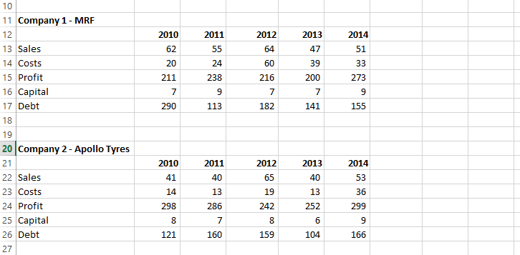

**Properly organize the data in the Sheet 2 for 5 Years**

*Sample:*

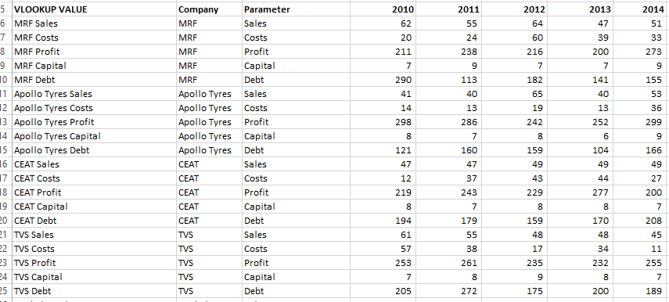

**Create and present your Dash board in the Sheet 3**

* Present your Dash board along with Chart

